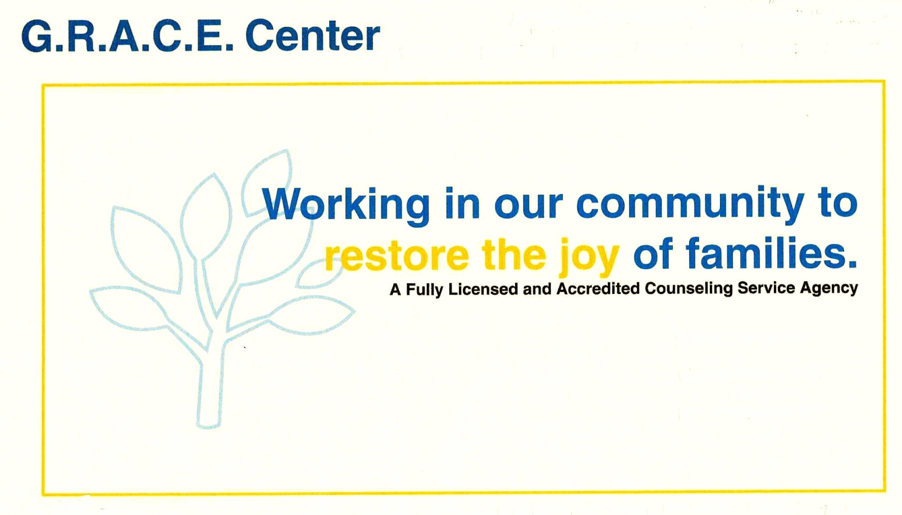

**GRACE CENTER ANNUAL REPORT**

**FY2021/2022**

MISSION STATEMENT:

G.R.A.C.E. Center is a service agency dedicated to improving the spiritual, emotional, mental, and social conditions of people in our geographical area. We provide counseling, referrals, and substance abuse prevention education, at a reasonable cost, to all seeking our services. Centered around unconditional love, we stand committed to positive personal growth, through professional excellence.

POPULATION SERVED

The staff provides counseling and prevention services to individuals, family members, and the community, relevant to the effects of substance abuse as well as personal growth issues. In addition to individual therapy and family therapy, clients may attend group therapy and/or didactic lectures, as these are available.

Admissions

New Clients:

FY2020/2021: 157

FY2021/2022: 123

Direct Staff Hours:

FY2020/2021: 7,042

FY2021/2022: 8,465

Staff Utilization Rates:

Agency Average: 60% Goal: 50%

* Total number of new clients decreased by 22% over the previous year. However, there

were more returning clients than in previous years.

* Total number of hours increased by 17% post-COVID.
* Overall total Utilization Rates (UR’s) for staff stayed relatively the same, decreasing by 1%.
* Administration hours increased by 11% due to the hiring of the Administrative Assistant.

GOALS/OBJECTIVES

GOAL 1: EXPAND INSURANCE OPPORTUNITIES

Objective 1: Explore contracts with other insurance companies. There was minimal effort

in this objective; mainly due to the CARF accreditation issues in going digital. This objective

is going to be revisited in FY2022/2023.

GOAL 2: DIGITIZE OFFICE SYSTEMS

Objective 1: To continue to move paper records to digital systems.

* Therapy Notes. Therapy Notes is a digital tool to enter client records and take therapy

progress notes from paper to digital. The agency began work on this project at the end

of FY2020/2021 and continued to finalize the process in FY2021/2022. With the hiring

of the new Administrative Assistant, the agency streamlined the client paperwork process

from intake to discharge.

* CARF Survey. CARF, our accreditation organization, made the last-minute decision to

digitize the Survey process. With no help from CARF, the agency managed to upload its

Organizational Manual to the CARF on-line system.

Objective 2: Pursue on-line Accounting Systems. More research is needed in this venture.

It is the Administrative Director’s goal to have a new accounting platform up and running

by the end of FY2022/2023

FUNDING STREAMS

Contractual Resources:

* Northern Michigan Regional Entity
* Michigan Department of Health & Human Services
* Michigan Department of Community Corrections
* Meridian Health Plan
* McLaren Health Plan
* Health Management Systems
* Client Paid Fees

Grants/Donations:

* Episcopal Diocese of Eastern Michigan
* St. Francis Episcopal Church
* Alden & Vada Dow Family Foundation
* Crawford County United Way
* Private Donations

COMMUNITY ORGANIZATIONS

Regular Meetings/Collaborations:

* Crawford County Collaborative Body
* Northern Michigan Regional Entity (NMRE) Provider’s Meetings
* FAN (Families Against Narcotics Meetings

CONSUMER SATISFACTION SURVEYS

|  |  |  |  |  |  |  |  |  |  |
| --- | --- | --- | --- | --- | --- | --- | --- | --- | --- |
|  |  |  |  |  | Previous Year |  | Current Year |  | TREND |
|  |  |  |  |  |  |  |  |  |  |
| % over 18 | | | | | 100% |  | 100% |  | same |
| % Abstinent from alcohol/street drugs in last 30 days | | | | | 99% |  | 100% |  | +1% |
| % no arrests or charges in last 60 days | | | |  | 95% |  | 100% |  | +5% |
| % working or in school | | |  |  | 80% |  | 90% |  | +10% |
| % report timely access | | |  |  | 100% |  | 100% |  | same |
| % found services helpful | | |  |  | 99% |  | 100% |  | same |
| % found office staff courteous and compassionate | | | | | 100% |  | 100% |  | same |
| % who would recommend GRACE | | | |  | 100% |  | 100% |  | same |
| Average Job or school attendance rating | | | |  | 4.73 |  | 4.00 |  | -.73 |
| Average effectiveness dealing with stress or anger | | | | | 3.84 |  | 3.85 |  | +.01 |
| Average overall relationships | | |  |  | 4.03 |  | 4.00 |  | -.01 |
| Average overall quality of life | | |  |  | 3.92 |  | 4.00 |  | +.08 |
| (3=Average) | |  |  |  |  |  |  |  |  |

|  |  |  |  |  |  |  |  |  |  |  |  |  |
| --- | --- | --- | --- | --- | --- | --- | --- | --- | --- | --- | --- | --- |
| Comments: |  |  |  |  |  |  |  |  |  |  |  |  |
|  | | |  |  |  |  |  |  |  |  |  |  |
| Would like group to come back.  Staff are kind and polite.  I wouldn’t change anything.  I had a positive experience.  Information on drug addiction very informative.  Staff answered all questions.  Top notch!  Informative, well-instructed. | | | | |  |  |  |  |  |  |  |  |
| *Due to the new digital format, the number of completed surveys were low. Once again we mailed  to discharged clients and received few in return. The on-line response was zero. We are looking  at ways to help us capture information once again. | | |  |  |  |  |  |  |  |  |  |  |
| ON-LINE CONSUMER TRENDS  In the on-line arena, Google demographics reports that 4 out of 5 clients would recommend  G.R.A.C.E. Center to other people. Viewing statistics show that 1,043 people had viewed the  agency web page in the past year. Some of the comments included:  “I was recommended to attend session for (marriage) by court. I was pretty hesitant  at first. After a while, I really made a commitment, an put serious effort in. My  counselor and I really get into a little bit of everything and I have learned many ways  to cope with my past behaviors. I love this place they really have me more than I  can say. Its hard for me to put it all into words. Let’s just say I would recommend  them to anyone who really wants a better life.”  “They are amazing, they listen an truly care about helping others. They don’t just sit  there an judge an not respond and are never negative, they sit there and help u thru  ur issues and provide amazing advice an explain things so clear to where u understand  which allows u to help figure out the underlying problem of why u do what u do. I would  always reccommend them to any an all people. They care about you if your willing to  take the chance to fix ur issues an get thru what ever your dealing with when it comes to  addiction or sobriety anger or depression their always there if ya need them.” | | | | | | |  |  |  |  |  |  |
| RISK MANAGEMENT REPORT  This past year the agency was in POST-COVID mode, trying to rebound from the pandemic by  offering both in-person and tele-health options for clients. Most clients kept to home and we  tried to devise new strategies to get them back in the office. The biggest issue we faced was  trying to find a new therapist. It was a perfect storm of sorts with COVID at the top of the list.  More people worked from home and decided to open up their own businesses. Also, a large number  of people, especially the “Baby Boomers” took early retirement, thinning the employee pool even  smaller. In addition to the retirements, there were even fewer graduates in the field. The agency  adopted some different ways to seek out prospective employees than it had in the past. It expended  a large amount of money to “Indeed” and didn’t get one resume.   * Finances. G.R.A.C.E. Center continues to be very active in its mission to secure finances in   order to continue operating. The agency was fairly successful in receiving the funding that  was requested. The addition of accepting credit cards cut the amount of money owed by  clients by almost 75%! Our biggest concern is the lack of a therapist bringing in more clients.   * Health & Safety. G.R.A.C.E. Center was fully open after being closed to in-person counseling   for over a year due to the pandemic. Staff are following all health/safety protocols in an effort  to minimize the communicable disease risk.   * Technology Needs. The purchase of Therapy Notes subscription gave the agency the virtual   tools to work with to offer flexible scheduling to our clientele. Therapists can complete the  progress notes and treatment plans on Therapy Notes as well. There have been a number of  processes that are more streamlined thanks in part to Therapy Notes. The agency continues to  re-vamp its client files from paper to digital. The next step is to upgrade the accounting system.   * Insurance Needs. G.R.A.C.E. Center is current with all insurance policies, including   Building, Workman’s Compensation and Professional Liability. | | | | | | | | | | | | |  |  |
|  | |  |  |  |  |  |  |  |  |  |  |  |
| * Trends in the Field. * Telehealth/Virtual Services * “Paperless” Files * Lack of Job-Seekers * New counseling therapies: EMDR, Domestic Violence/Anger Management     EXECUTIVE SUMMARY | | | | | |  |  |  |  |  |  |  |
| * Staffing* |  |  |  |  |  |  |  |  |  |  |  |  |
|  | | | | | | | | | |  |  |  |  |  |  |  |  |
| During the past fiscal year there were changes in staffing at the G.R.A.C.E Center.  .   * Kristen Todoroff, Clinical Director resigned in August 2022. * Jody Robson accepted the Clinical Director position September 2022. * Koreena Whitney began her internship in September 2022.   *On a side note, it continues to be incredibly hard to find the licensed professionals needed to grow  this agency. With the resignation of Kristen Todoroff, this is an additional challenge for the agency.  G.R.A.C.E. Center is not alone in this challenge. This is the norm throughout the state.   * Community Involvement * Community Coffee Hour * Chamber of Commerce Business After Hours * Grayling Promotional Association Festival of Trees * Virtual Expansion * Phone-based therapy. In FY2019/2020, the G.R.A.C.E. Center was forced to   to implement phone-based therapy due to the COVID pandemic as its primary  means of counseling. This method of therapy works well when the client  or therapist is unable to do face-to-face counseling.   * Virtual-based therapy. This past Fiscal Year, G.R.A.C.E. Center began   Offering virtual therapy. The new computers that were installed came with  video cameras that allowed virtual face-to-face counseling. | | | | | | | |  |  |  |  |  |  |  |  |

* Technology Upgrades. Due to providing counseling services virtually, the

agency upgraded its computers and software to meet the needs of our clients.

* Virtual “Paperwork”. The software recently purchased allows for paperless

client files, the ability to transfer forms back and forth, credit card processing

and client scheduling.

* Other Activities
* CARF (Commission on Accreditation of Rehabilitation Facilities. In August 2022, G.R.A.C.E. Center was surveyed for its 3 year Accreditation with CARF. The

survey was done completely on a virtual platform, which presented a lot of issues

for the staff and the CARF surveyor. The experience was interesting to say the

least. G.R.A.C.E. Center was awarded another 3-year Accreditation with a 96.7%

compliance rate of their standards.

Crawford County continues to be one of the poorest counties in Michigan, and it is likely to

continue for the unforeseeable future. It is the mission of G.R.A.C.E. Center to provide much-

needed services at a reasonable cost. Telehealth has changed how we operate and how we will

be a more cost-efficient agency in years to come. COVID-19 has forever changed how we relate

to our clients, staff and community stakeholders.

Respectfully submitted February 2, 2023:

_________________________________ __________________________________

Carol Moggo, Administrative Director Jody Robson, Clinical Director